A \*Algorithm

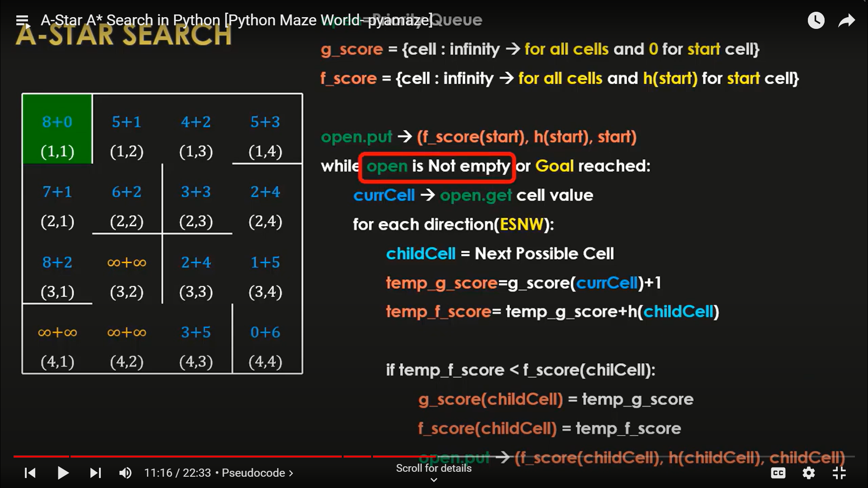

Let us now understand the algorithm

First we take a priority queue called open which is empty at the beginning, next

1)Let us start with the start cell

We first calculate the g cost and the h cost of the start cell. The g cost of the start cell will be 0 as the g cost is based upon the distance from the start cell.

Then we put three values into our open queue

1)The f score

2)The h score

3)The start cell itself

2)Next we run a while loop to look over the other cells

While either open is not empty or goal is reached we run the loop

Note: The first condition will only be true if there is no path to reach the goal

Then we move on to our next cell and get the priority value. Then for each cell in the east, north, south, west we calculate their f score

And then we compare the f score of all these cells and the one with the lowest f score as well as the highest priority is choosen.

And then we put this cell along with the f cost and h cost in our queue.

Then we keep on repeating this process.